Covid assignment in DataBricks

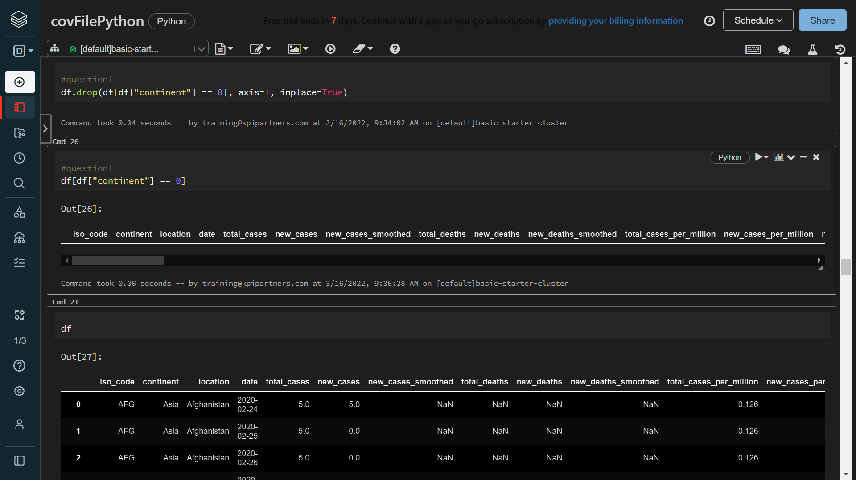1. Remove the records where the continent column having blanks

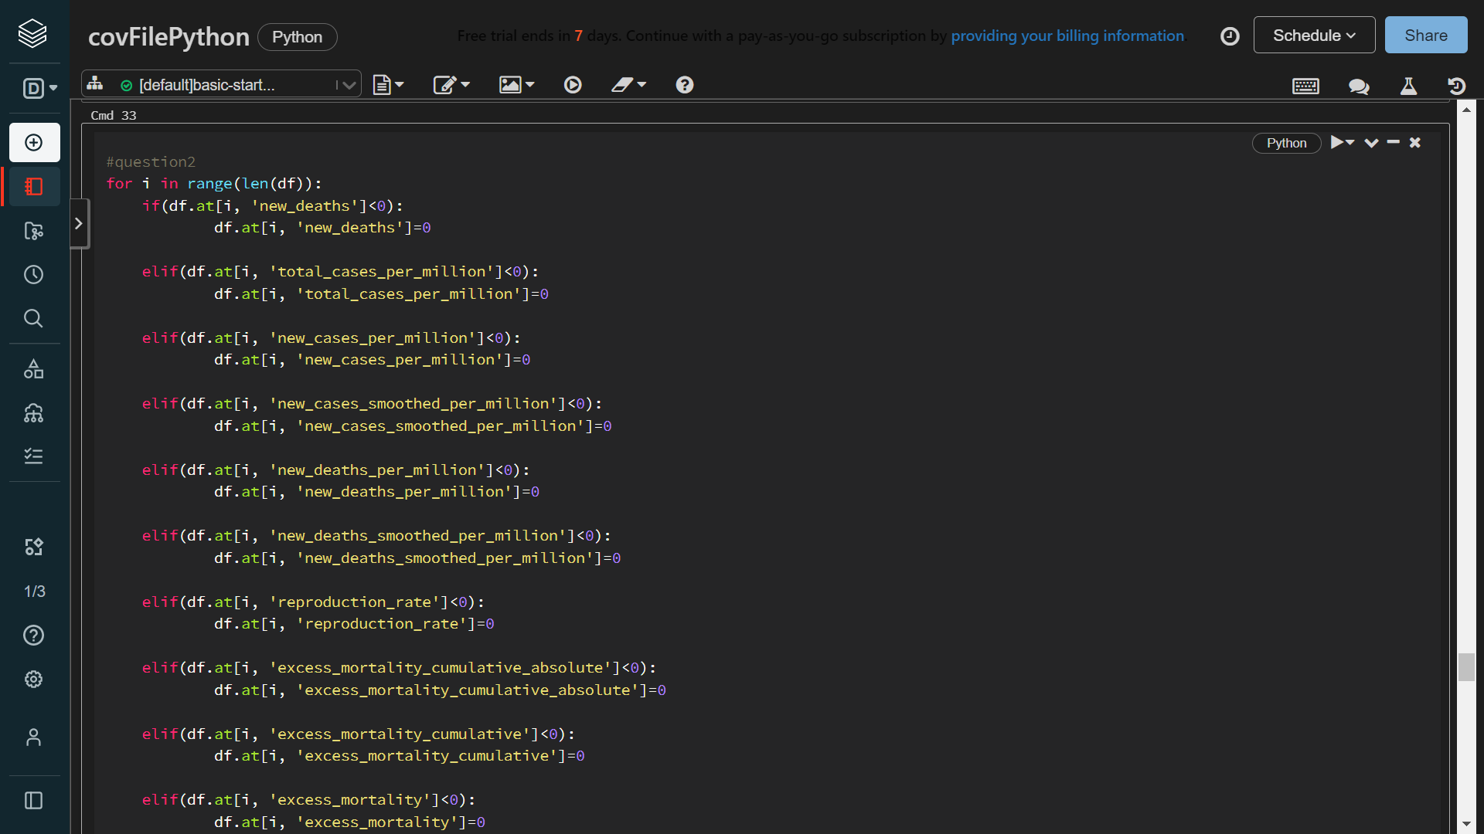2. Replace all the NEGATIVE and NULL valued records with 0

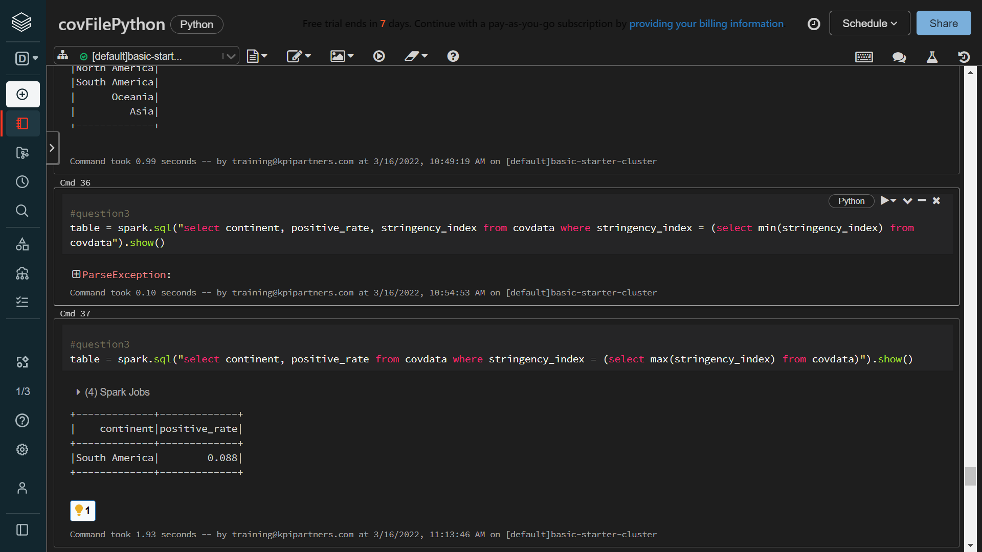3. Display the continent, positive_rate where the strigency_index is maximum

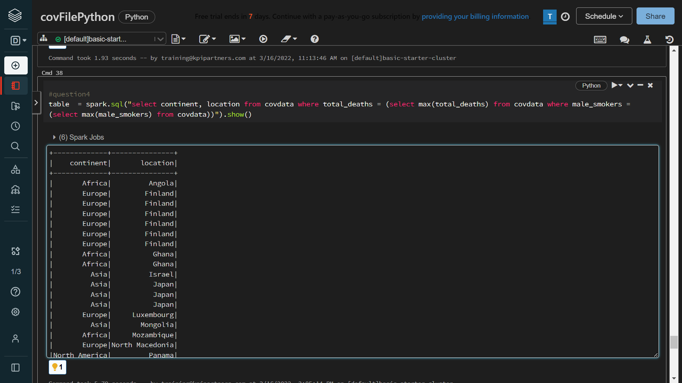4. Which continent and location having max of deaths and male_smokers?

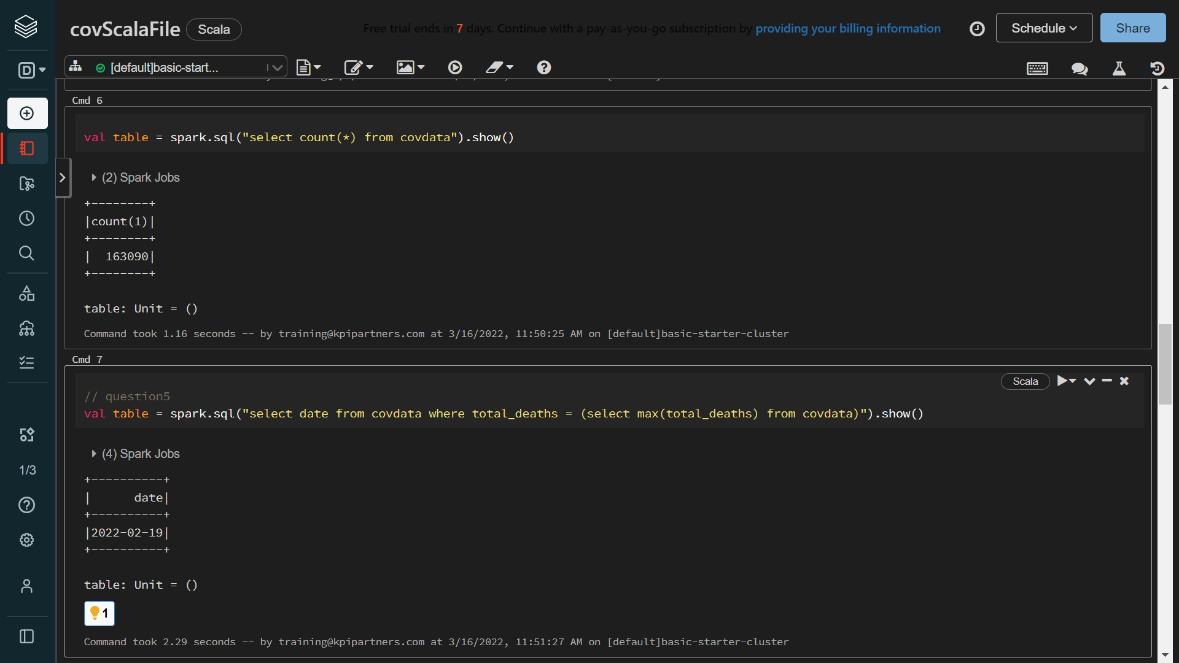5. Which year having the highest number of deaths?

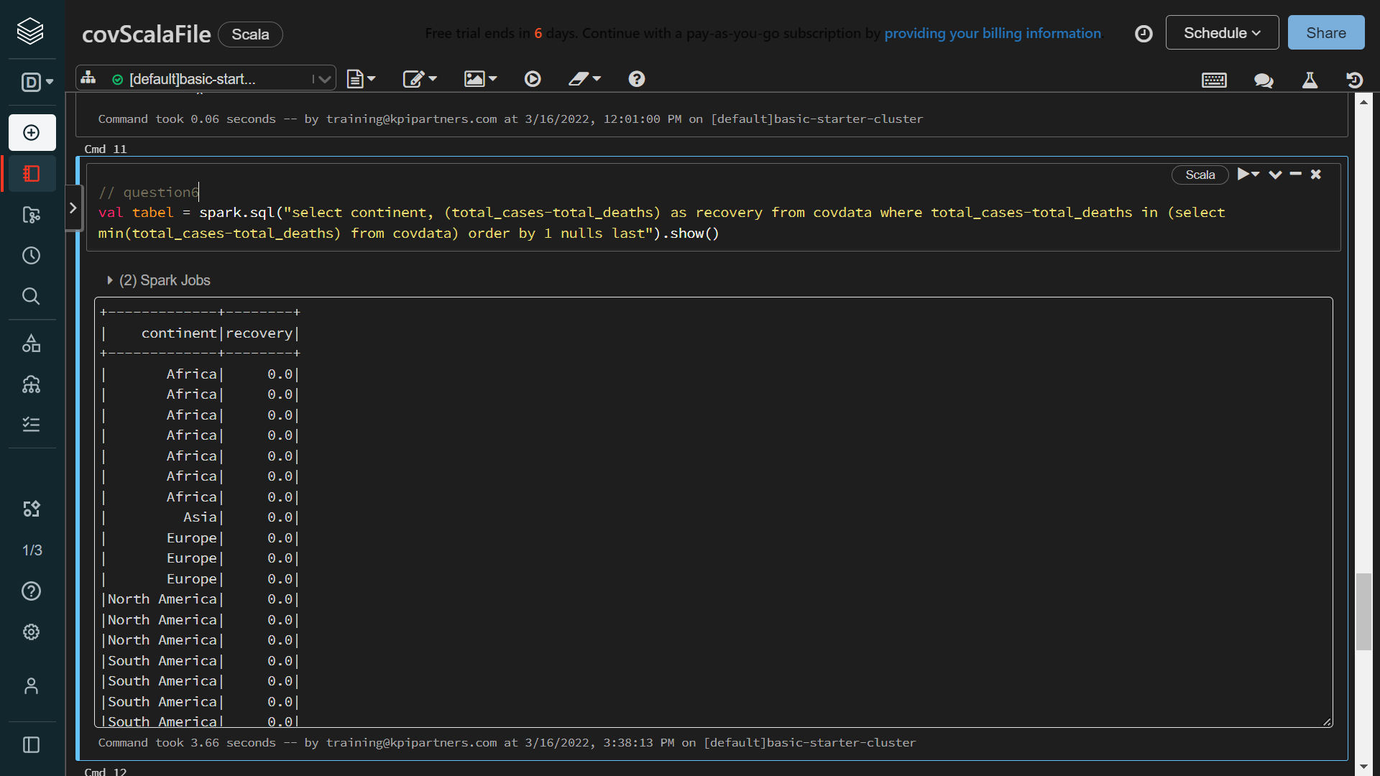6. Which location having lowest recovery rate for each continent?

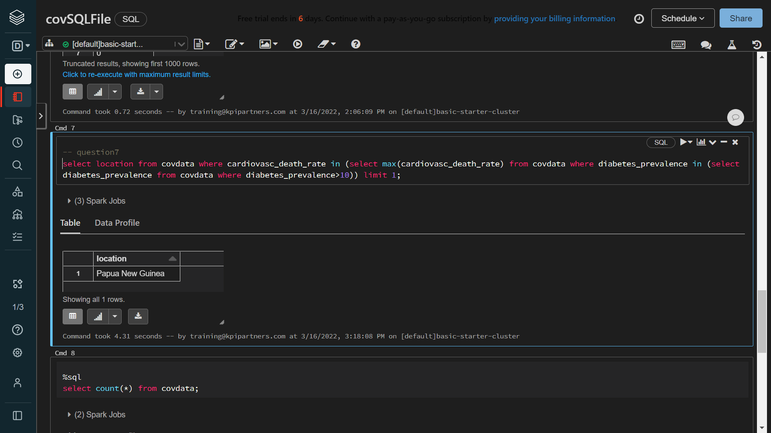7. Countries with max cardiovasc_death_rate and diabetes_prevalence greater than 10

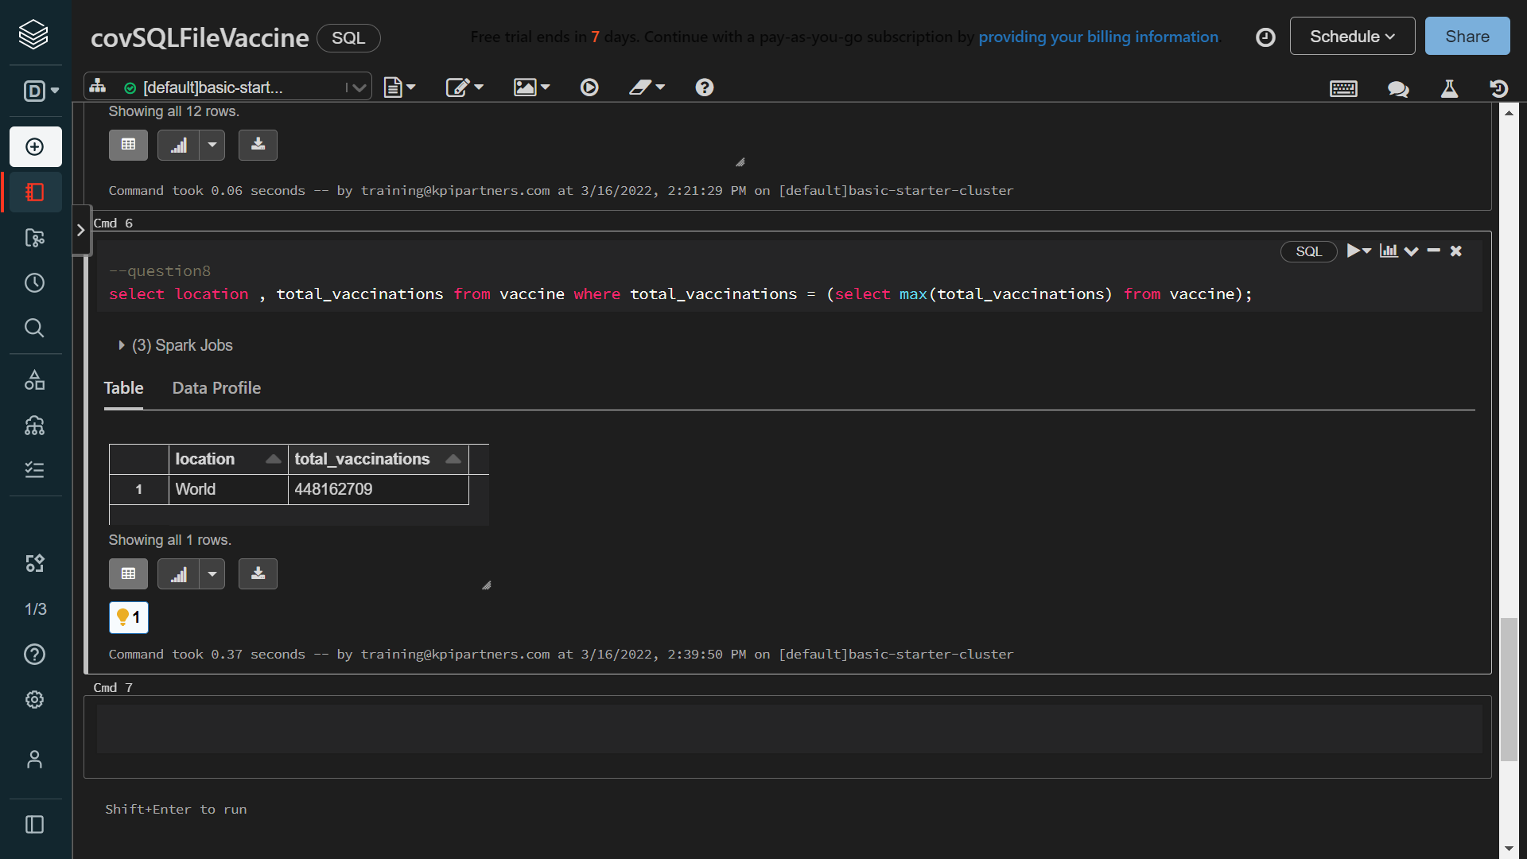8. Which location has highest number of vaccinated people in each continent?